Packet Tracer – Propagating a Default Route in EIGRP for IPv4 and IPv6

1. Topology

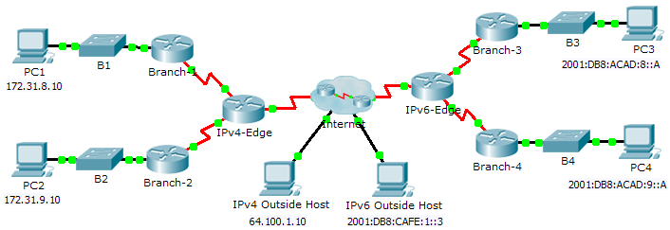

1. Addressing Table

|  |  |  |  |
| --- | --- | --- | --- |
| Device | Interface | IPv4 Address | Subnet Mask |
| IPv6 Address/Prefix | |
| IPv4-Edge | S0/0/0 | 172.31.6.1 | 255.255.255.0 |
| S0/0/1 | 172.31.7.1 | 255.255.255.0 |
| S0/1/0 | 209.165.200.226 | 255.255.255.224 |
| Branch-1 | G0/0 | 172.31.8.1 | 255.255.255.0 |
| S0/0/0 | 172.31.6.2 | 255.255.255.0 |
| Branch-2 | G0/0 | 172.31.9.1 | 255.255.255.0 |
| S0/0/1 | 172.31.7.2 | 255.255.255.0 |
| IPv6-Edge | S0/0/0 | 2001:DB8:ACAD:7::1/64 | |
| S0/0/1 | 2001:DB8:ACAD:6::1/64 | |
| S0/1/0 | 2001:DB8:CAFE:ABCD::2/164 | |
| Branch-3 | G0/0 | 2001:DB8:ACAD:8::1/64 | |
| S0/0/0 | 2001:DB8:ACAD:7::2/64 | |
| Branch-4 | G0/0 | 2001:DB8:ACAD:9::1/64 | |
| S0/0/1 | 2001:DB8:ACAD:6:::2/64 | |

1. Objectives

Part 1: Propagate an IPv4 Default Route

Part 2: Propagate an IPv6 Default Route

Part 3: Verify Connectivity to Outside Hosts

1. Scenario

In this activity, you will configure and propagate a default route in EIGRP for IPv4 and IPv6 networks. EIGRP is already configured. However, you are required to configure an IPv4 and an IPv6 default route. Then, you will configure the EIGRP routing process to propagate the default route to downstream EIGRP neighbors. Finally, you will verify the default routes by pinging hosts outside the EIGRP routing domain.

1. Propagate a Default Route in EIGRP for IPv4
   1. Verify EIGRP configuration on each IPv4 enabled router.

Display the routing table of each IPv4 enabled router and verify that all IPv4 routes are visible.

* 1. Configure an IPv4 default route.

Configure a directly connected IPv4 default route on **IPv4-Edge**.

* 1. Propagate the default route in EIGRP.

Configure the EIGRP routing process to propagate the default route.

* 1. Verify IPv4 default route is propagating.

Display the routing tables for **Branch-1** and **Branch-2** to verify the default route is now installed.

1. Propagate a Default Route in EIGRP for IPv6
   1. Verify EIGRP configuration on each IPv6 enabled router.

Display the routing table of each IPv6 enabled router and verify that all IPv6 routes are visible.

* 1. Configure an IPv6 default route.

Configure a directly connected IPv6 default route on **IPv6-Edge**.

* 1. Propagate the default route in EIGRP.

Configure the EIGRP routing process to propagate the default route.

* 1. Verify IPv6 default route is propagating.

Display the routing tables for **Branch-3** and **Branch-4** to verify the default route is now installed.

1. Verify Connectivity to Outside Hosts

* **PC1** and **PC2** should now be able to ping **IPv4 Outside Host**.
* **PC3** and **PC4** should now be able to ping **IPv6 Outside Host**.